Use Case - Document

# Title:

Policy holder Registration

# Description:

The Use Case allow policyholder to add Policy No, Period of Insurance with From and To date, Name of the Insured, Gender, Address, Date of birth, Phone No, Email.

# Use Case Diagram:

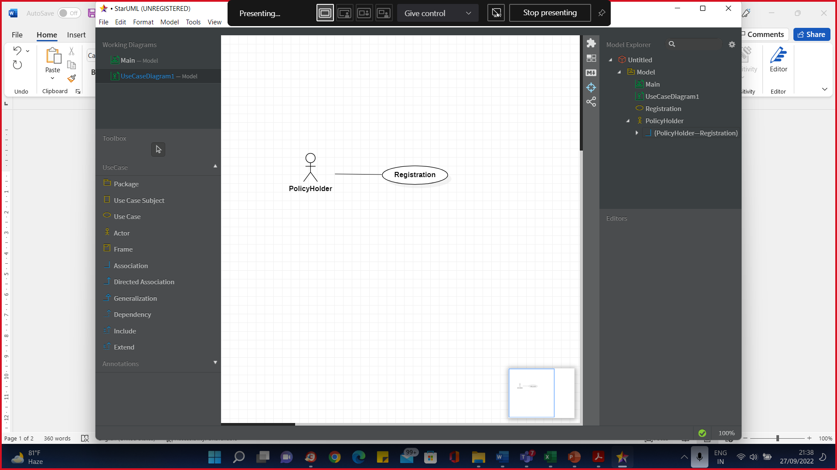

# Pre-Conditions:

# Post-Conditions:

1. The complete information about Policy Holder is added to database on successful creation.

# Primary Flow:

1. Use Case Starts when a Policyholder chooses to register
2. The system request that actor enter registration details
3. The System validates provided information
4. The System checks if policyholder information already exists or not
5. The system stores registration information
6. The system displays message to the actor
7. Use case ends

# Alternate Flow:

1. Policyholder information is not valid
   * If the policyholder information is not valid (Policy No, Period of Insurance with From and To date etc), the system displays an error message.

Actor can choose to either return to beginning of primary flow or cancel registering at which point use case ends

1. Policy number is already found
   * If policy number is already exist, the system displays an error message
   * Actor can choose to either return to beginning of primary flow or cancel registration at which point use case ends

# 

# Exception Flow:

1. Database system connectivity problem
   * If system is unable to communicate with database system, the system will attempt to reconnect with database system after specified period. If there is failure to connect after fixed number of attempts, the system displays an error message. Actor can choose to either return to beginning of primary flow or cancel registration at which point use case ends.

# Data:

Policy No, Period of Insurance with From and to date, Name of the Insured, Gender, Address, Date of birth, Phone No, Email.

# Special Requirements:

none

# Extension Points:

none